Web Programming – Lab Assignment 2
Student Name: Avyakth Shriram
Register Number: 24BCE5461

TASK 1 – HTML:

<!DOCTYPE html>
<html lang="en">
<head>
<meta charset="UTF-8">
<meta name="viewport" content="width=device-width, initial-scale=1.0">
<title>Text Forms</title>
<link rel="stylesheet" href="styles.css">
</head>
<body>
<form action="/test" method="get">
<label for="first_name">First Name:</label>
<input type="text" name="first_name" id="first_name" placeholder="Enter first name"><br>
<label for="last_name">Last Name:</label>
<input type="text" name="last_name" id="last_name" placeholder="Enter last name"><br>
<input type="submit" value="Submit Name">
</form>
<br>
<form action="/test" method="get">
<label for="username">Username:</label>
<input type="text" name="username" id="username" size="30" maxlength="50" placeholder="Enter username"><br>
<label for="password">Password:</label>
<input type="password" name="password" id="password" size="30" maxlength="50" placeholder="Enter password"><br>
<input type="submit" value="Login to Account">
</form>
<br>
<form>
<label for="description">Description:</label><br>
<textarea name="description" id="description" rows="5" cols="40" placeholder="Enter description here..."></textarea><br>
<input type="submit" value="Submit Description">
</form>
</body>
</html>

TASK 1 – CSS:

body {
font-family: Arial, sans-serif;
background-color: #f4f4f4;
margin: 0;
padding: 20px;
}
form {
background: white;
padding: 20px;
border-radius: 5px;
box-shadow: 0 2px 10px rgba(0, 0, 0, 0.1);
margin-bottom: 20px;
}
label {
display: block;
margin-bottom: 5px;
font-weight: bold;
}
input[type="text"], input[type="password"], textarea {
width: 100%;
padding: 10px;
margin-bottom: 10px;
border: 1px solid #ccc;
border-radius: 4px;
}
input[type="submit"] {
background-color: #5cb85c;
color: white;
border: none;
padding: 10px 15px;
border-radius: 4px;
cursor: pointer;
}
input[type="submit"]:hover {
background-color: #4cae4c;
}

TASK 1 – Screenshot of Webpage:
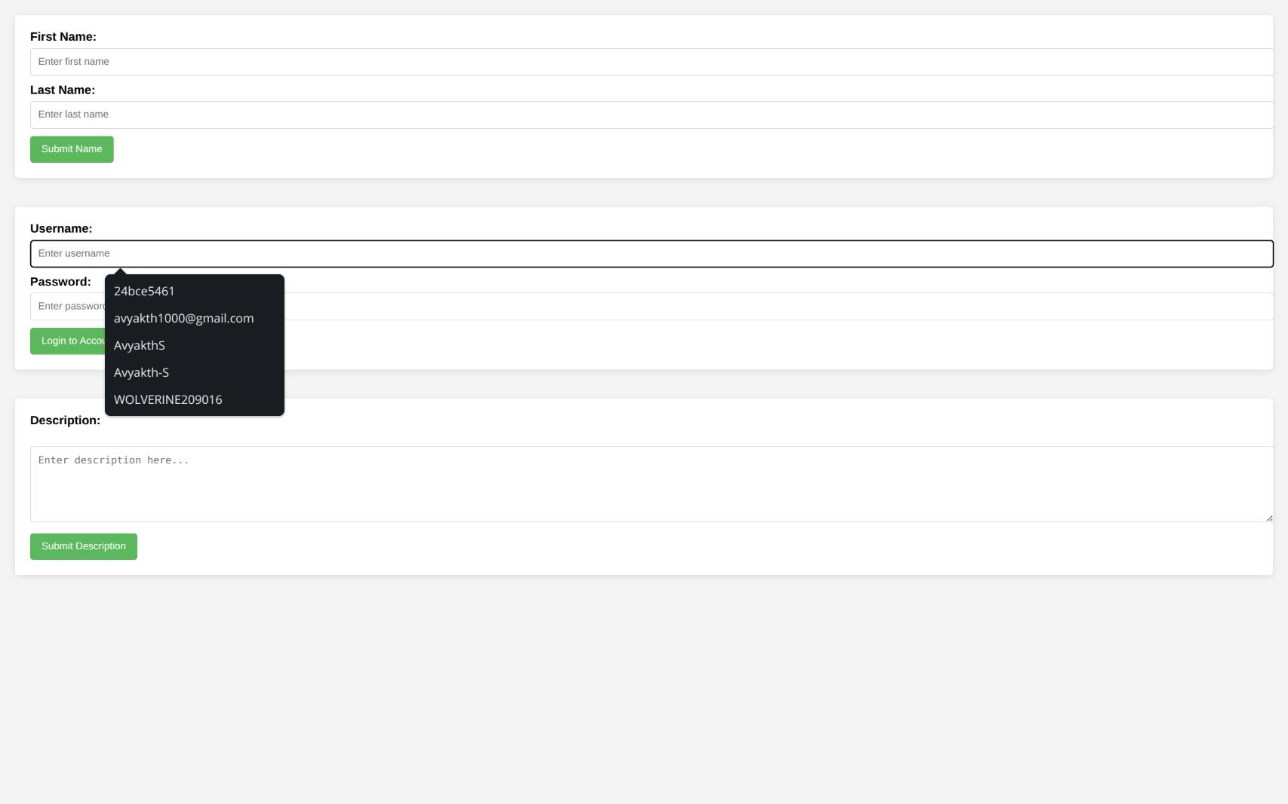

TASK 2 – HTML:

<!DOCTYPE html>
<html>
<head>
<title>Non-Text Forms</title>
<link rel="stylesheet" href="styles.css">
</head>
<body>
<form action="/test" method="get">
Select your gender:<br>
<input type="radio" name="gender" value="male"> Male<br>
<input type="radio" name="gender" value="female"> Female<br>
<input type="radio" name="gender" value="other"> Other<br>
<input type="radio" name="gender" value="prefer_not_say"> Prefer not to say<br>
<input type="submit" value="Submit Gender">
</form>
<br>
<form action="/test" method="get">
Select your hobbies:<br>
<input type="checkbox" name="hobby_reading" value="reading"> Reading<br>
<input type="checkbox" name="hobby_traveling" value="traveling"> Traveling<br>
<input type="checkbox" name="hobby_gaming" value="gaming"> Gaming<br>
<input type="checkbox" name="hobby_cooking" value="cooking"> Cooking<br>
<input type="submit" value="Submit Hobbies">
</form>
<br>
<form action="/test" method="get">
Choose your country:
<select name="country">
<option value="usa">USA</option>
<option value="canada">Canada</option>
<option value="uk">UK</option>
<option value="india">India</option>
<option value="australia">Australia</option>
<option value="other">Other</option>
</select><br>
<input type="submit" value="Submit Country">
</form>
</body>
</html>

TASK 2 – CSS:

:root{
--bg:#f3f7fb;
--card:#ffffff;
--primary:#0069c0;
--primary-dark:#0056a3;
--muted:#6b7280;
--radius:10px;
}

*{box-sizing:border-box}

body {
font-family: Inter, system-ui, -apple-system, "Segoe UI", Roboto, "Helvetica Neue", Arial;
background: linear-gradient(180deg,var(--bg),#eef6ff 60%);
margin: 0;
padding: 32px;
color: #0f172a;
-webkit-font-smoothing:antialiased;
}

.container{
max-width:760px;
margin:0 auto;
}

form {
background: var(--card);
padding: 22px;
border-radius: var(--radius);
box-shadow: 0 8px 30px rgba(16,24,40,0.08);
margin-bottom: 22px;
border: 1px solid rgba(2,6,23,0.04);
}

form > p, form > label{
margin:0 0 10px 0;
color:var(--muted);
font-weight:600;
}

input[type="radio"], input[type="checkbox"]{
transform:translateY(2px);
margin-right:8px;
}

select{
display:inline-block;
min-width:180px;
padding:8px 10px;
border-radius:8px;
border:1px solid #d1d5db;
background:#fff;
}

input[type="submit"]{
background:linear-gradient(180deg,var(--primary),var(--primary-dark));
color:#fff;
border:none;
padding:10px 16px;
margin: 10px 0 0 0;
border-radius:8px;
cursor:pointer;
font-weight:600;
box-shadow:0 6px 18px rgba(2,25,72,0.12);
transition:transform .12s ease, box-shadow .12s ease;
}

input[type="submit"]:hover{
transform:translateY(-2px);
box-shadow:0 10px 26px rgba(2,25,72,0.14);
}

select:focus, input[type="submit"]:focus {
outline: 3px solid rgba(0,105,192,0.14);
outline-offset: 3px;
}

@media (max-width:520px){
body{padding:18px}
form{padding:16px}
.container{padding:0 6px}
input[type="submit"]{width:100%}
}

TASK 2 – Screenshot of Webpage:
